# Azure Blob Storage

# 

## **Tutorial**

In this tutorial we will be adding some blob storage to our Azure account.

### **New Resource Group**

The first thing is to create a new resource group, which we can do by clicking the burger bar in the top left corner and choosing Resource groups:

Then, we can click +Add:

Here, we can name the resource group and pick a location to have it in:

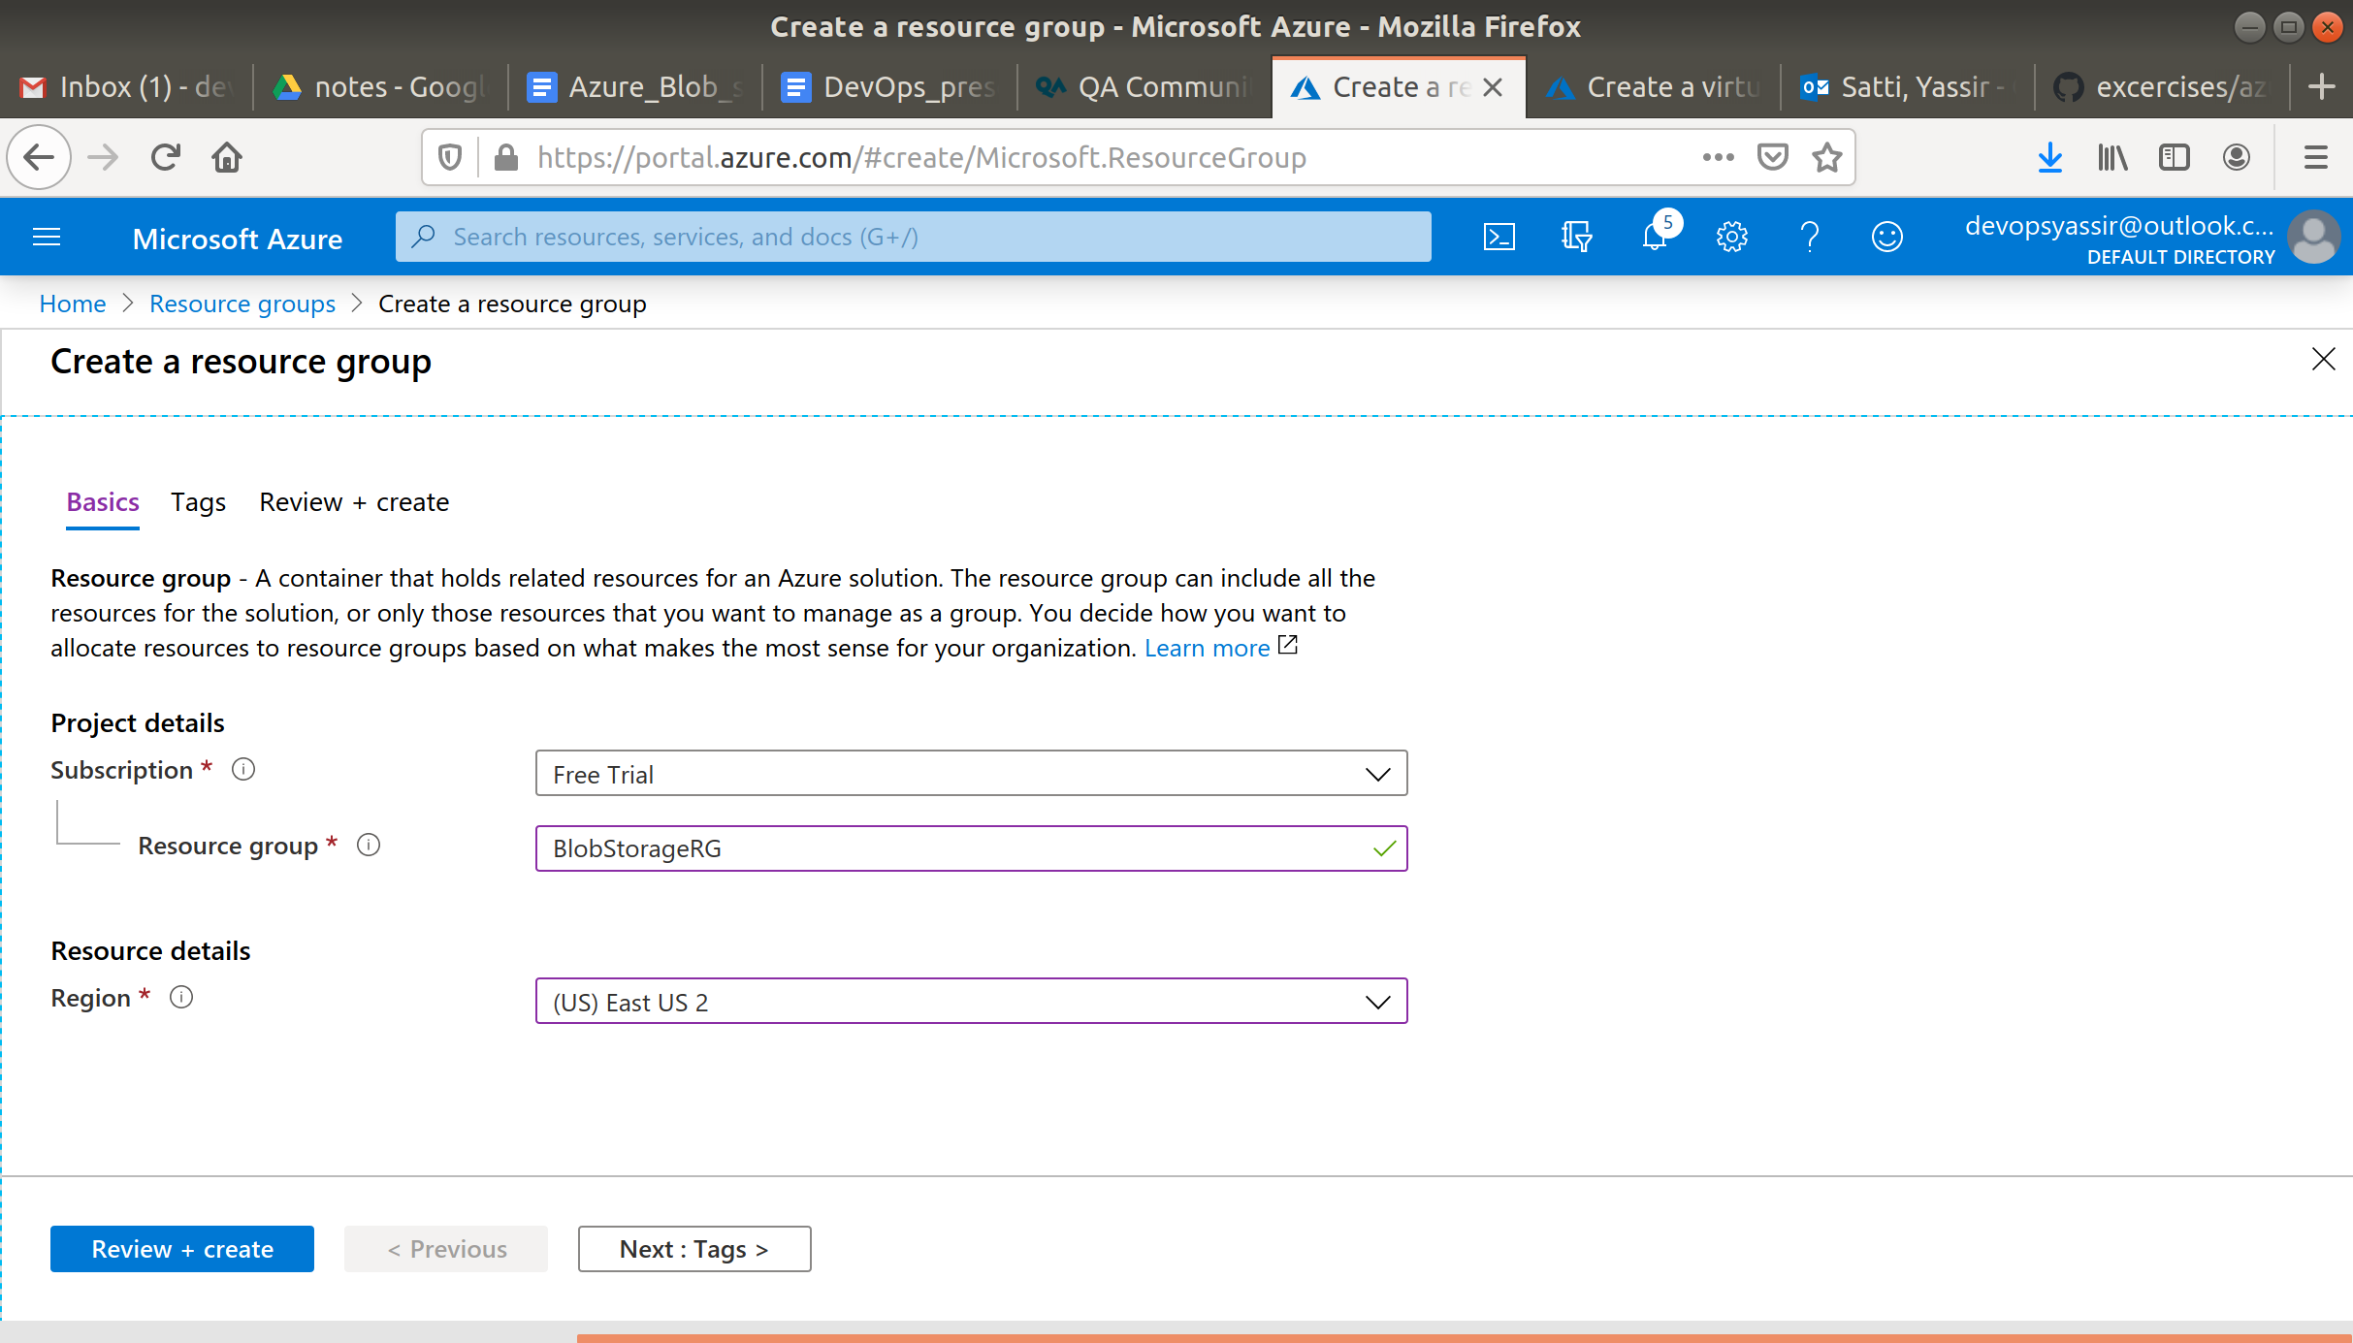

Lastly, we will click Review & Create and then Create to create the resource group:

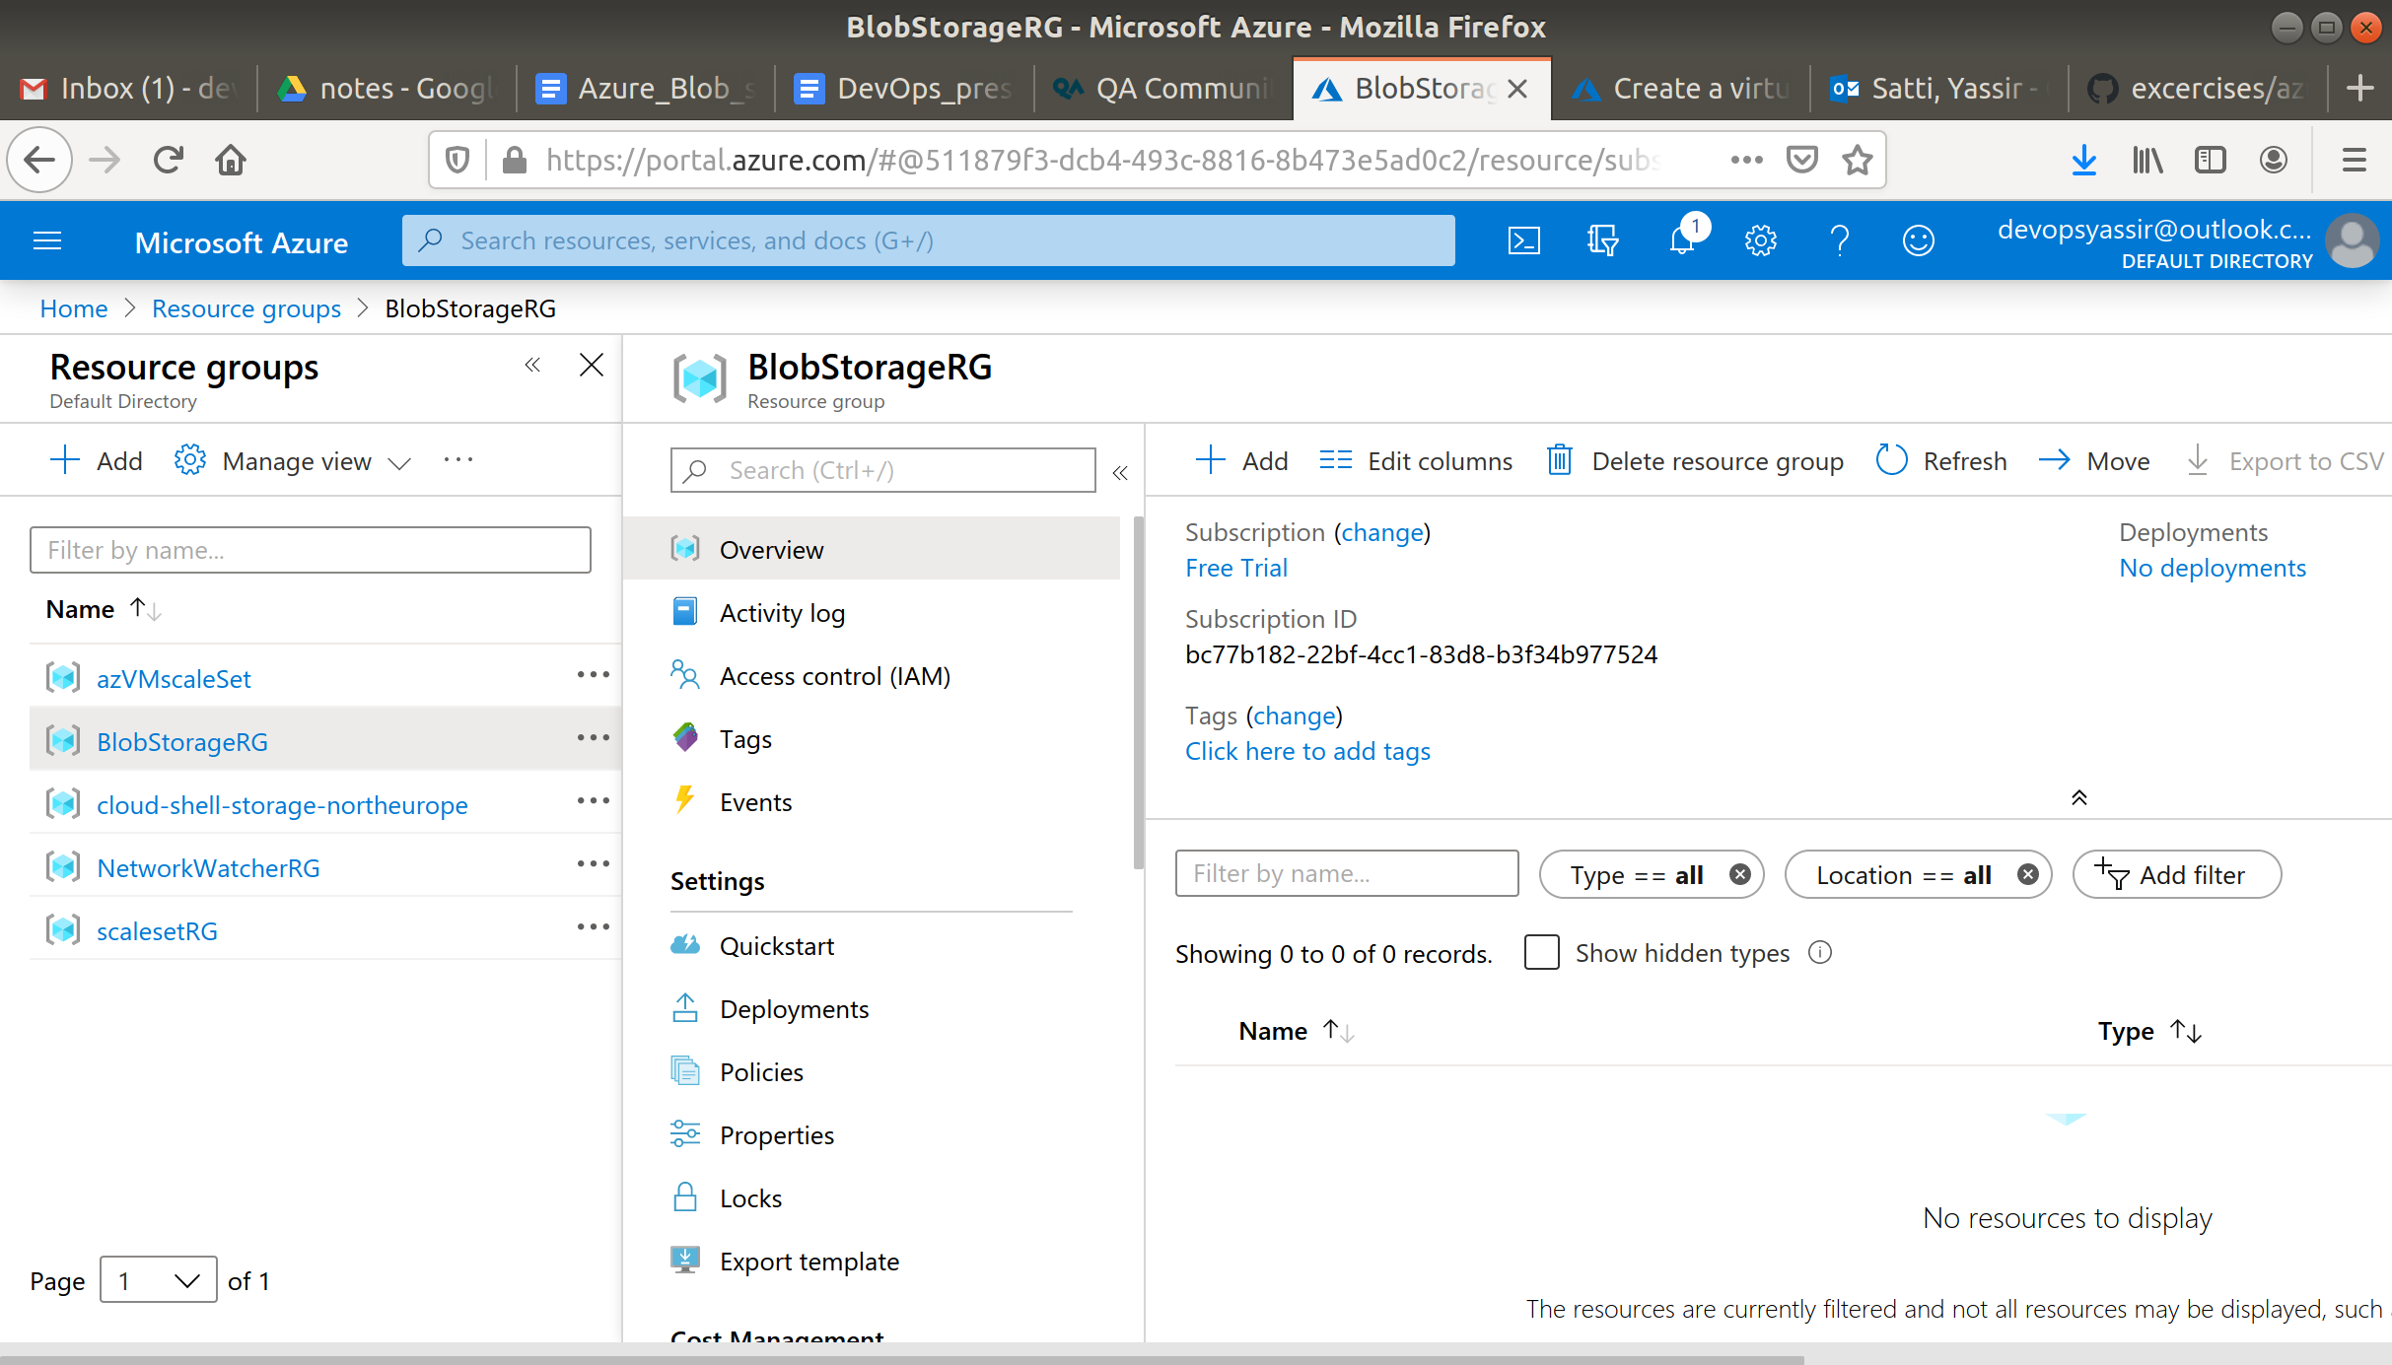

### **Storage Account**

Next we will create a storage account.

Type Storage Accounts in the search bar and click it when it appears.

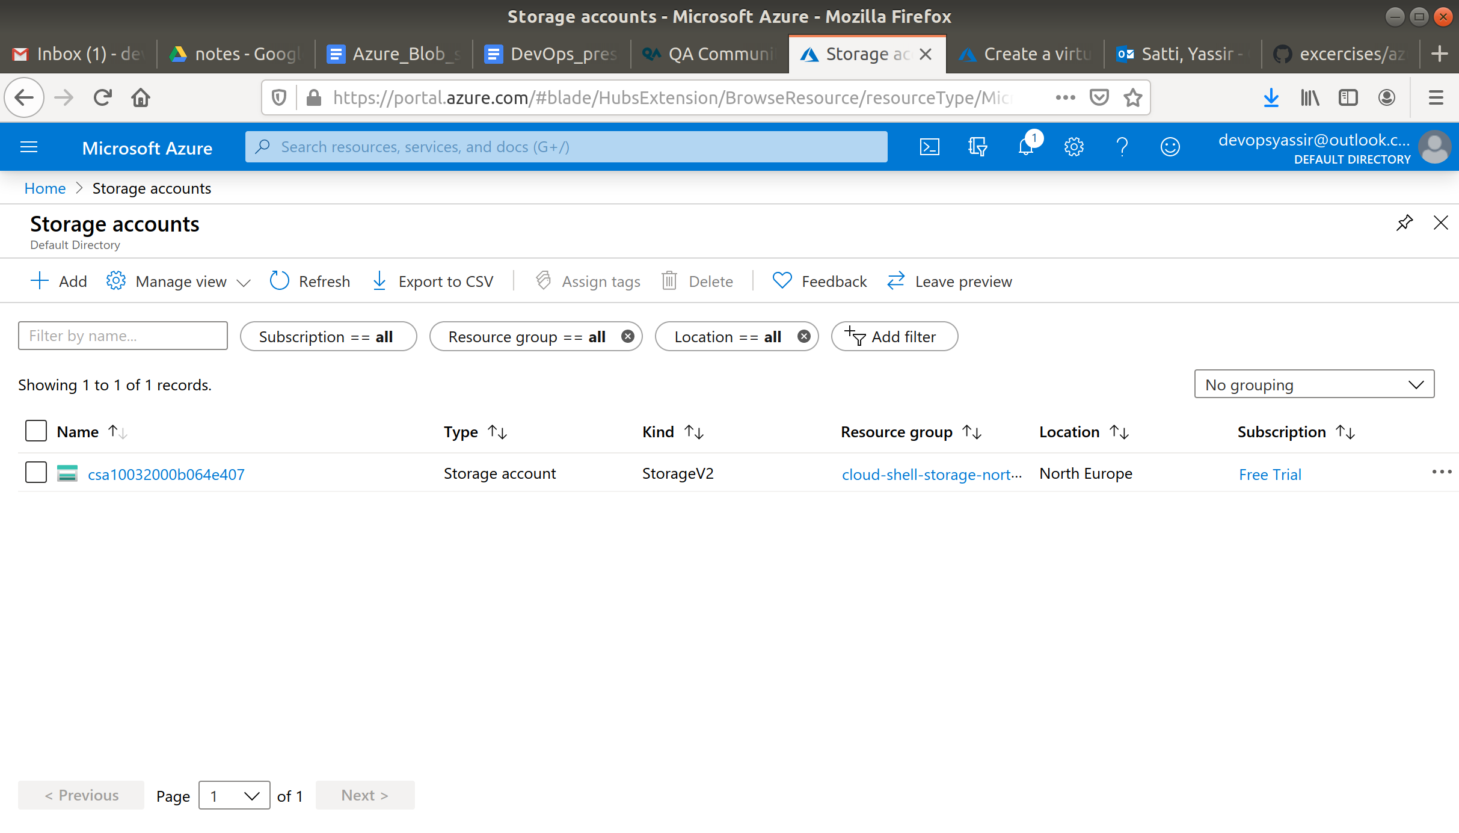

Now click **+Add**.

In the field enter the following:

* Resource Group - The resource group we created
* Storage Account Name - Anything you like, must be **Unique**, can only contain lowercase letters and numbers
* Location - UK South

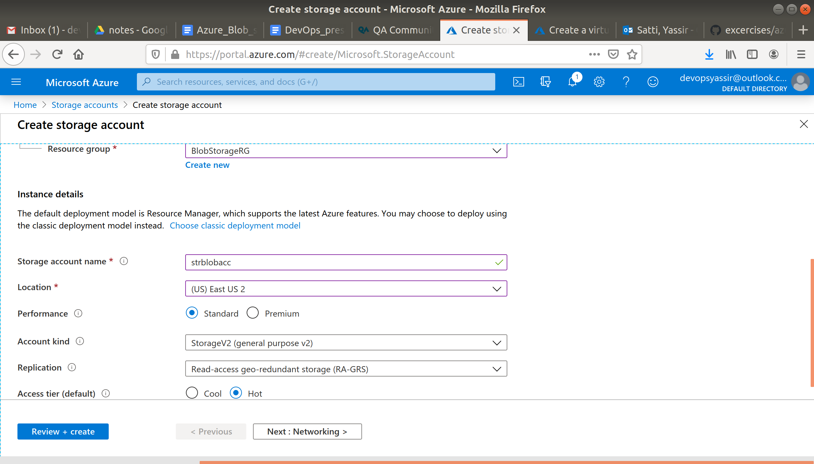

Leave the rest as default. And click **Review and Create**.

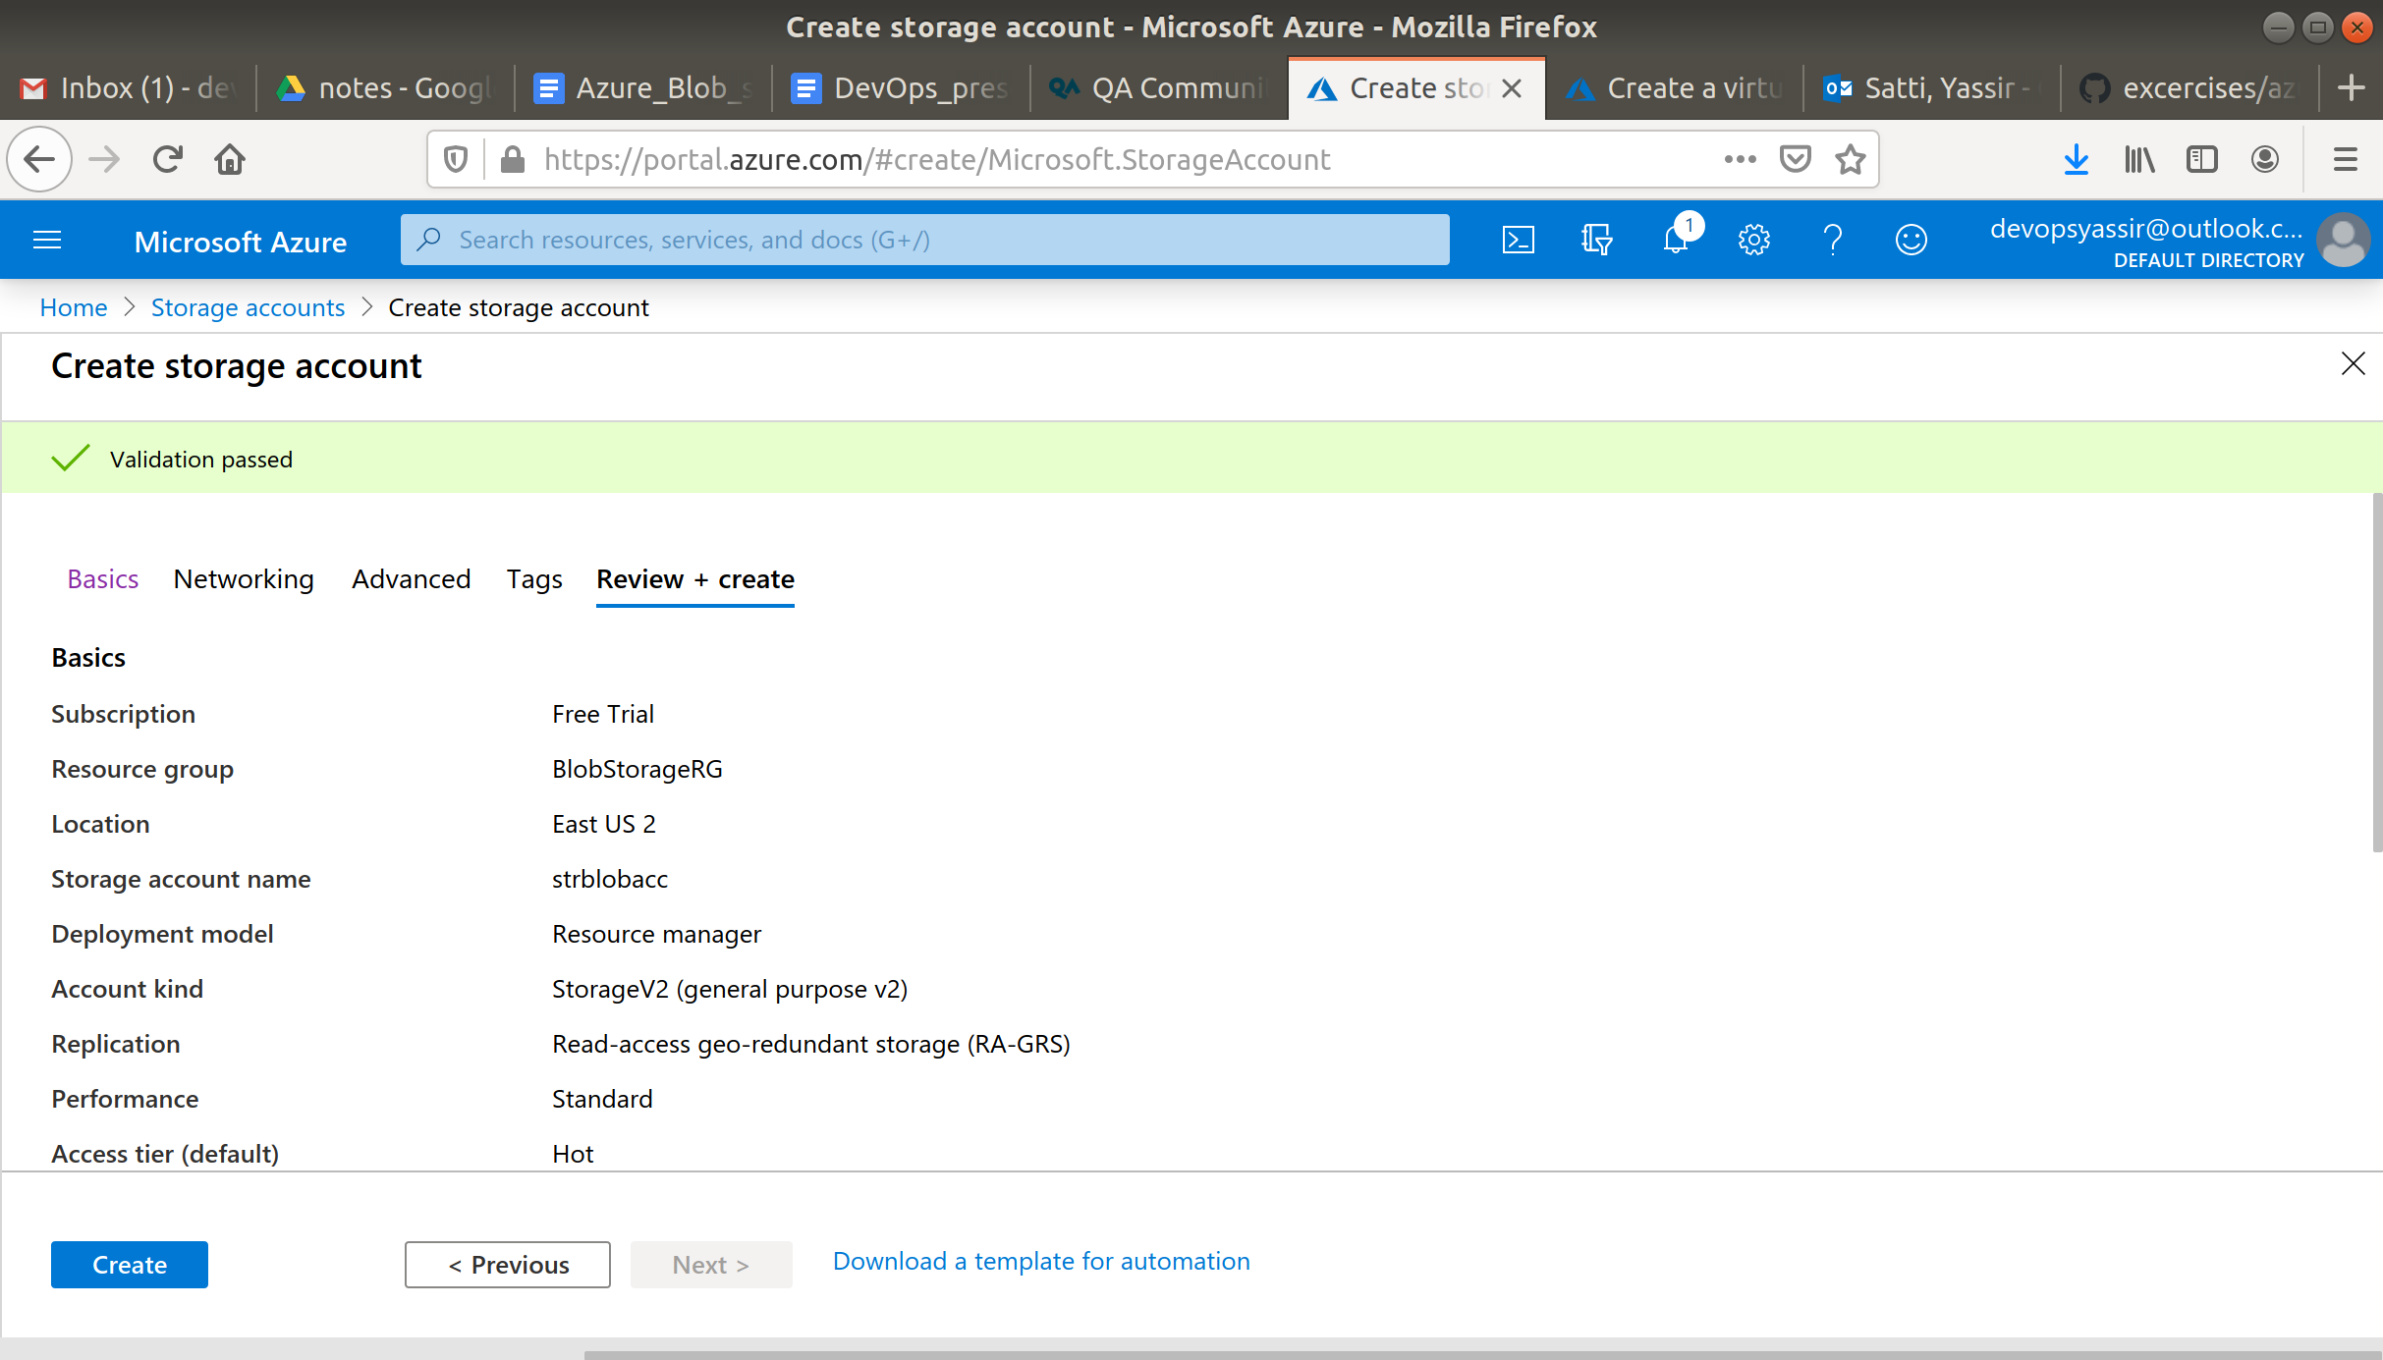

Then when the validations pass, click **Create**.

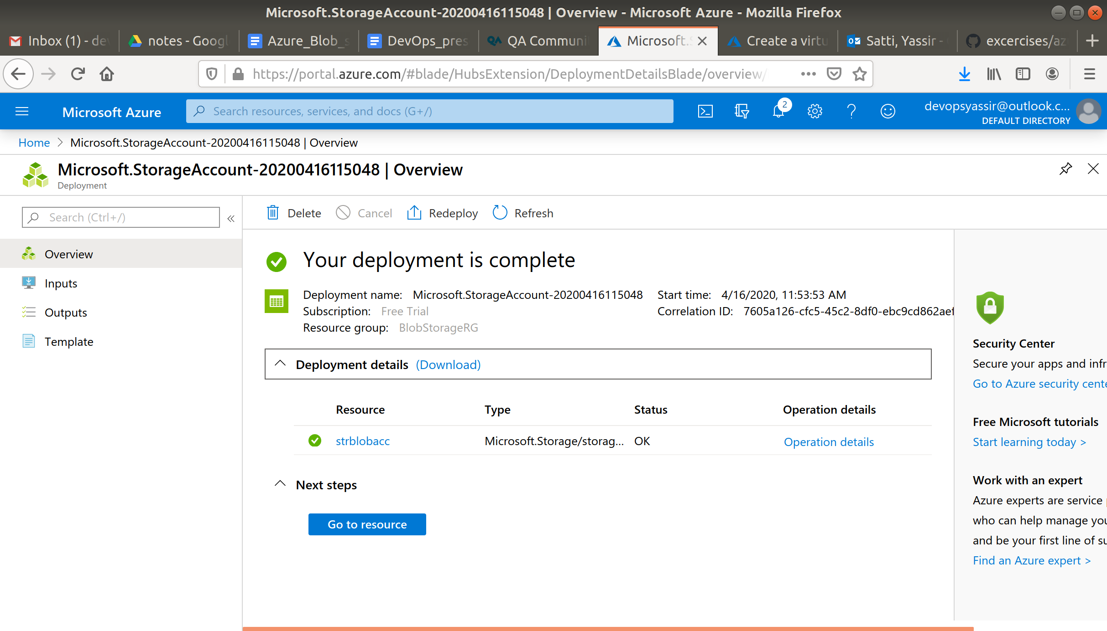

### **Adding a Container**

Navigate to the Storage Account you just created.

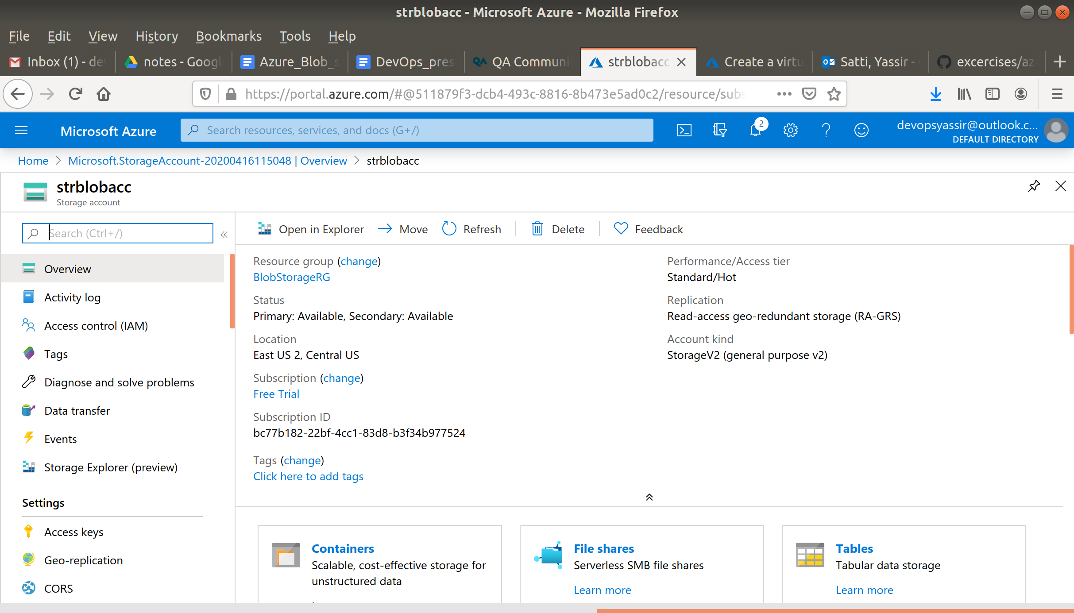

In the left pane select **Containers** under Blob service.

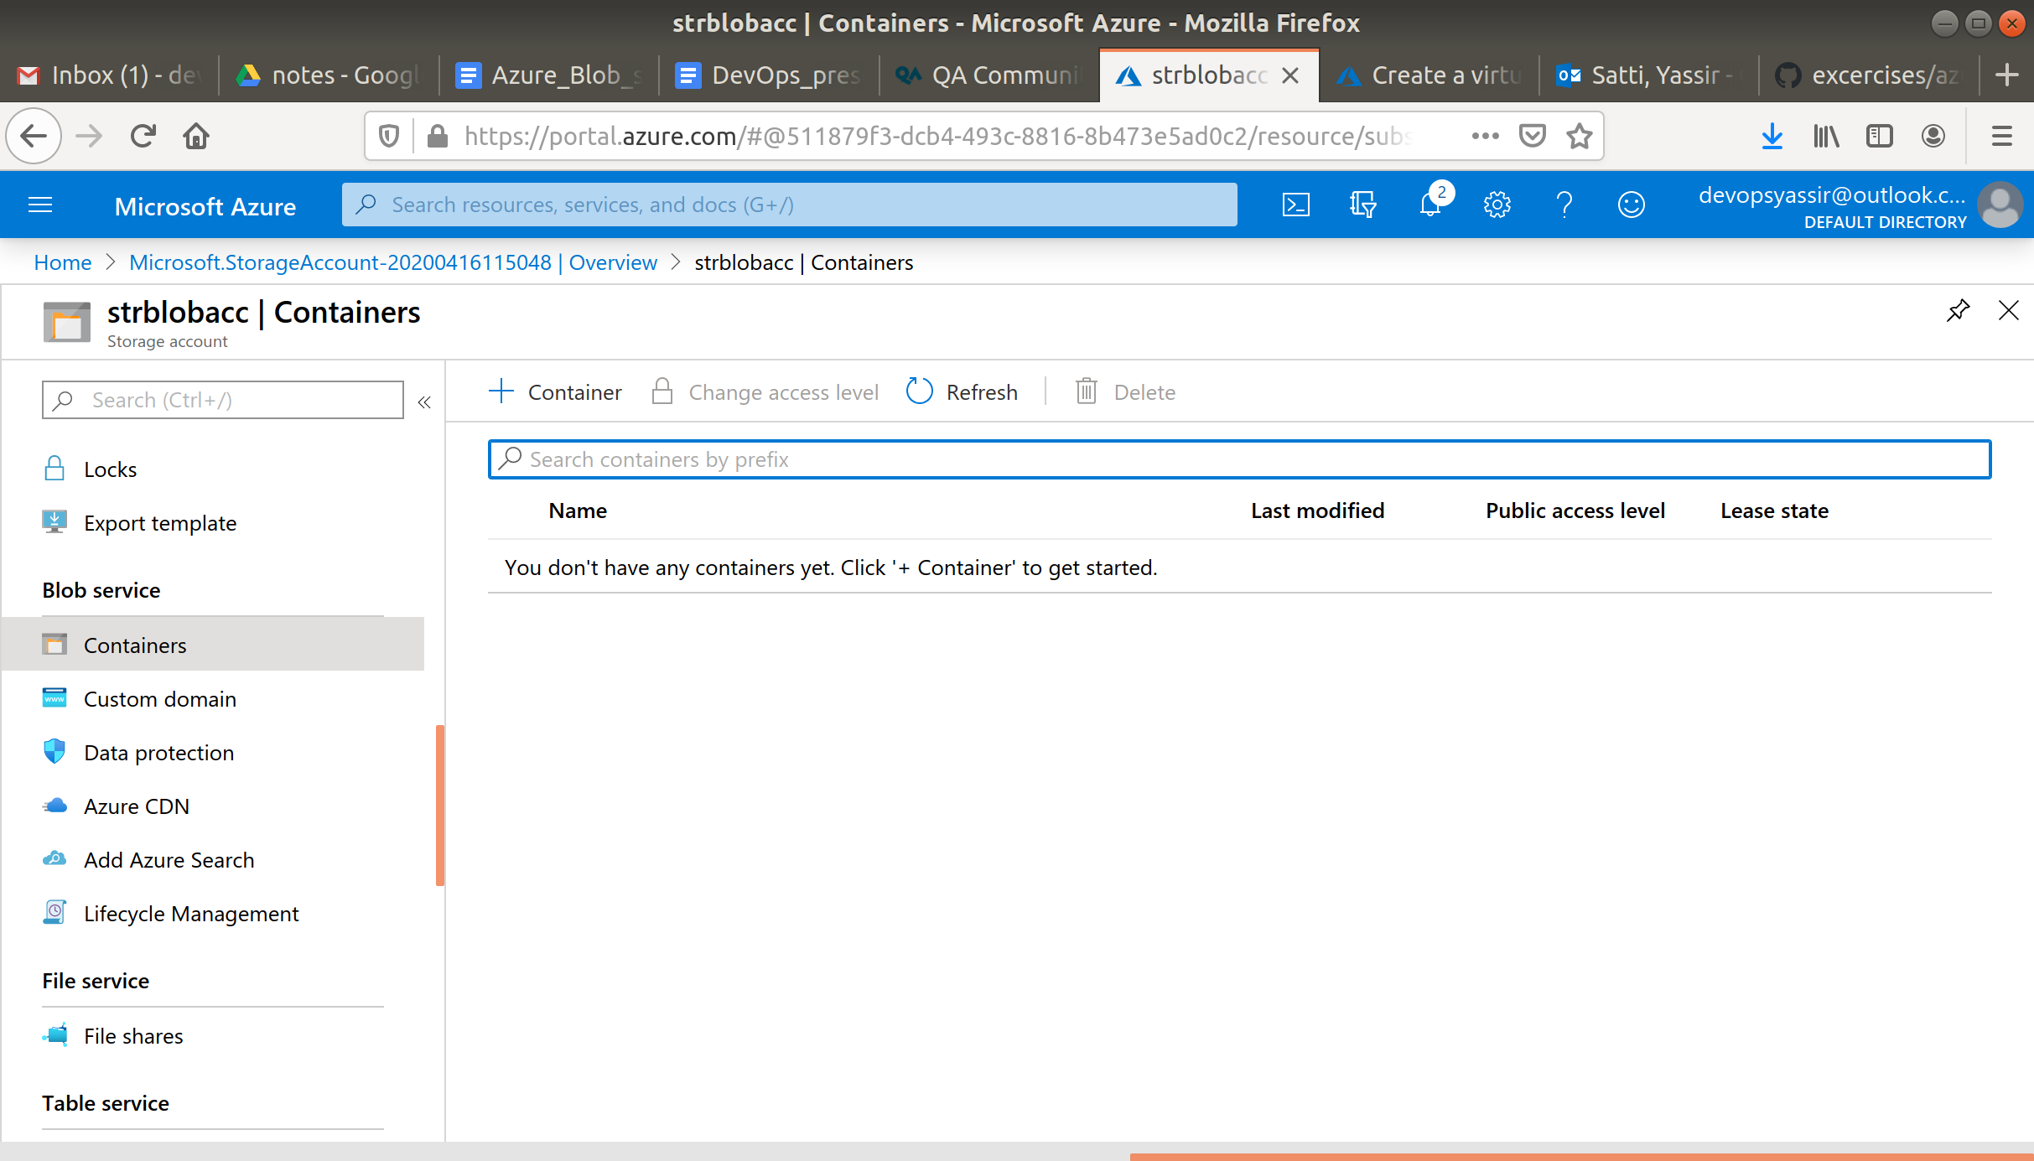

Then click + to create a new container and enter the name **blob-container**. And click **Ok**.

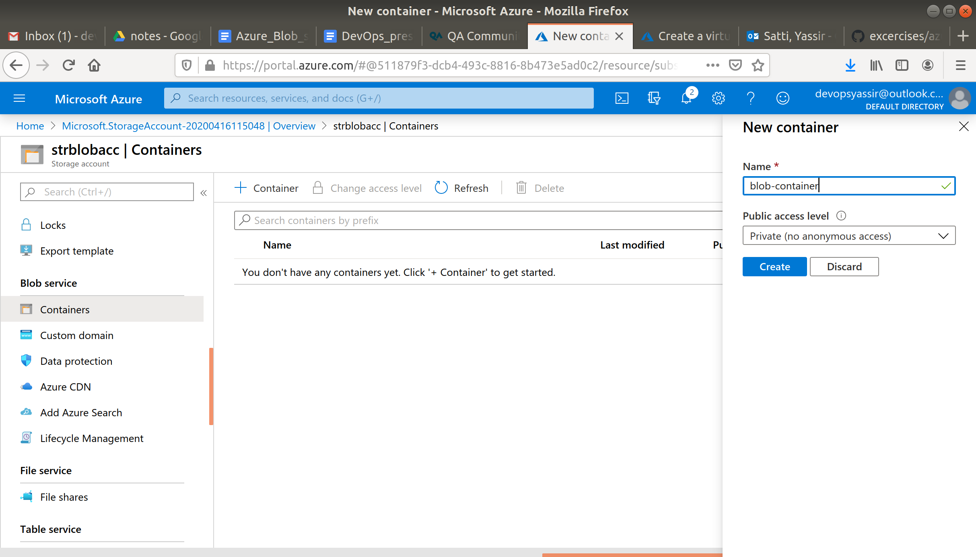

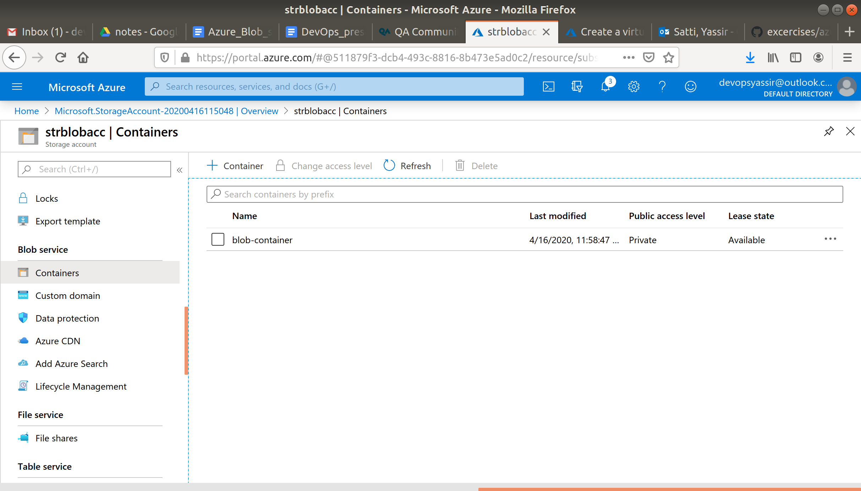

Now click on your container and click **Upload**.

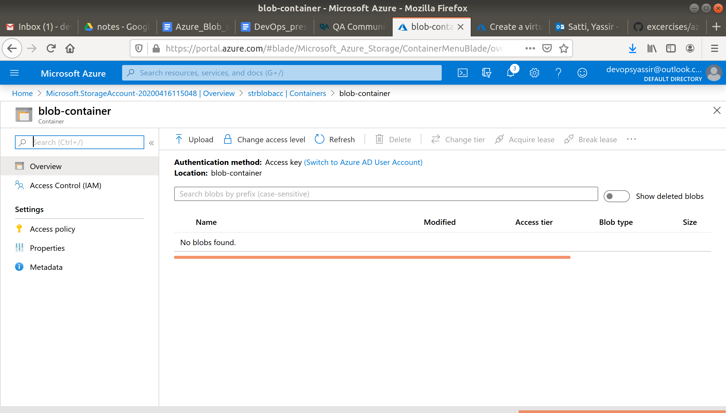

Now a window will appear with the option to select a file.

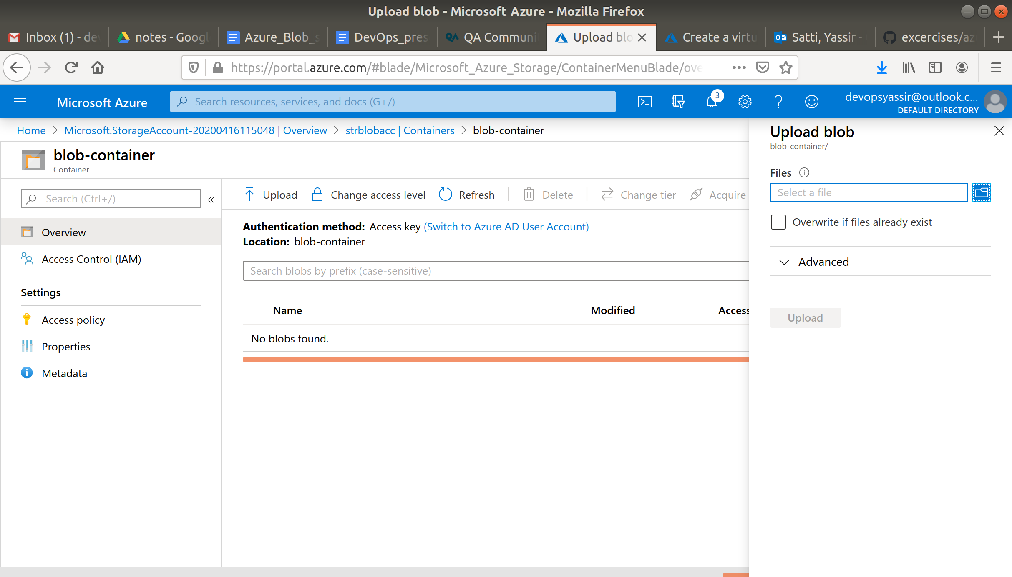

Select any image file (You may have to download them).

Then click **Upload**.

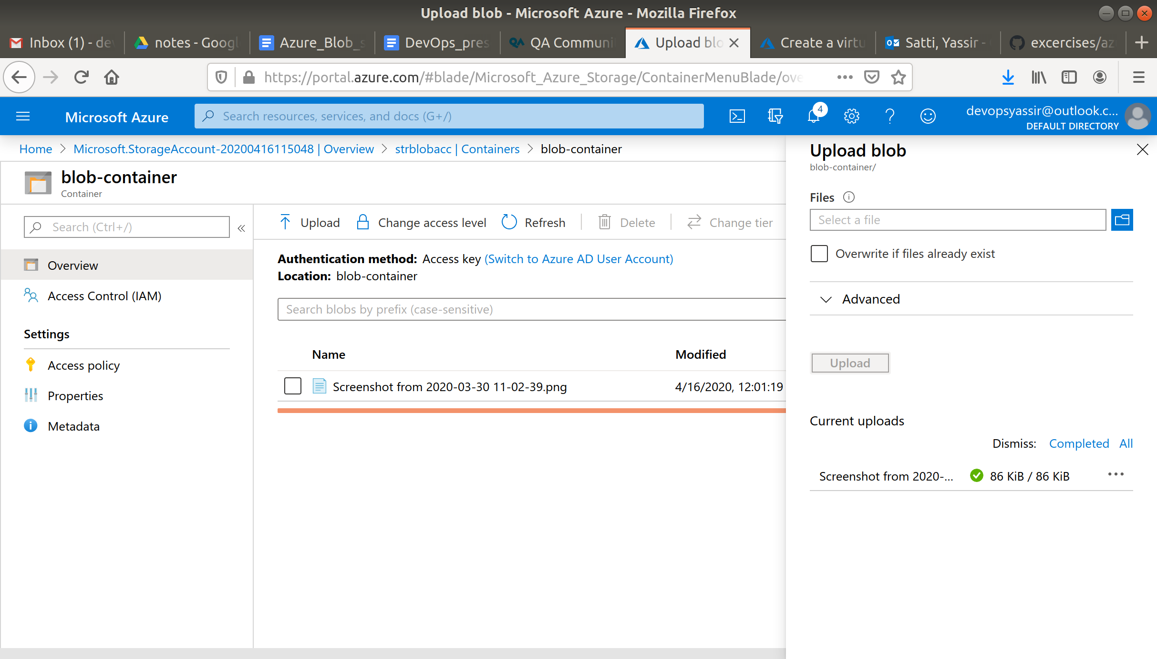

You have now added some blob storage to your storage account.

Now to allow access for users go to overview on the left side, then select “change access access level”

under public access level option select “container (anonymous read access for containers and blobs)” then click OK

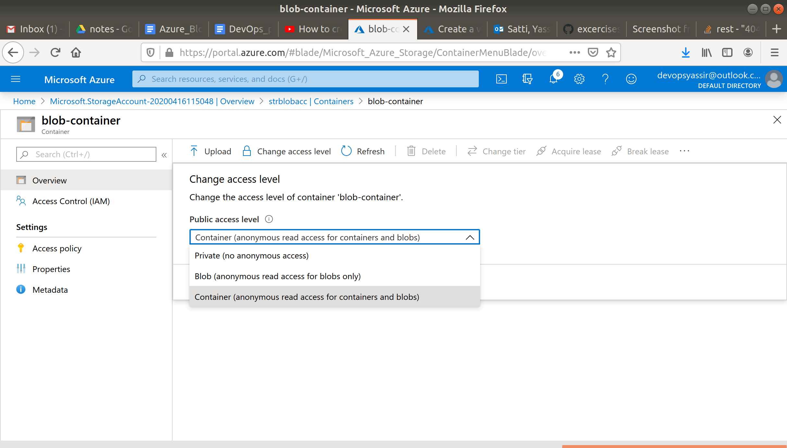

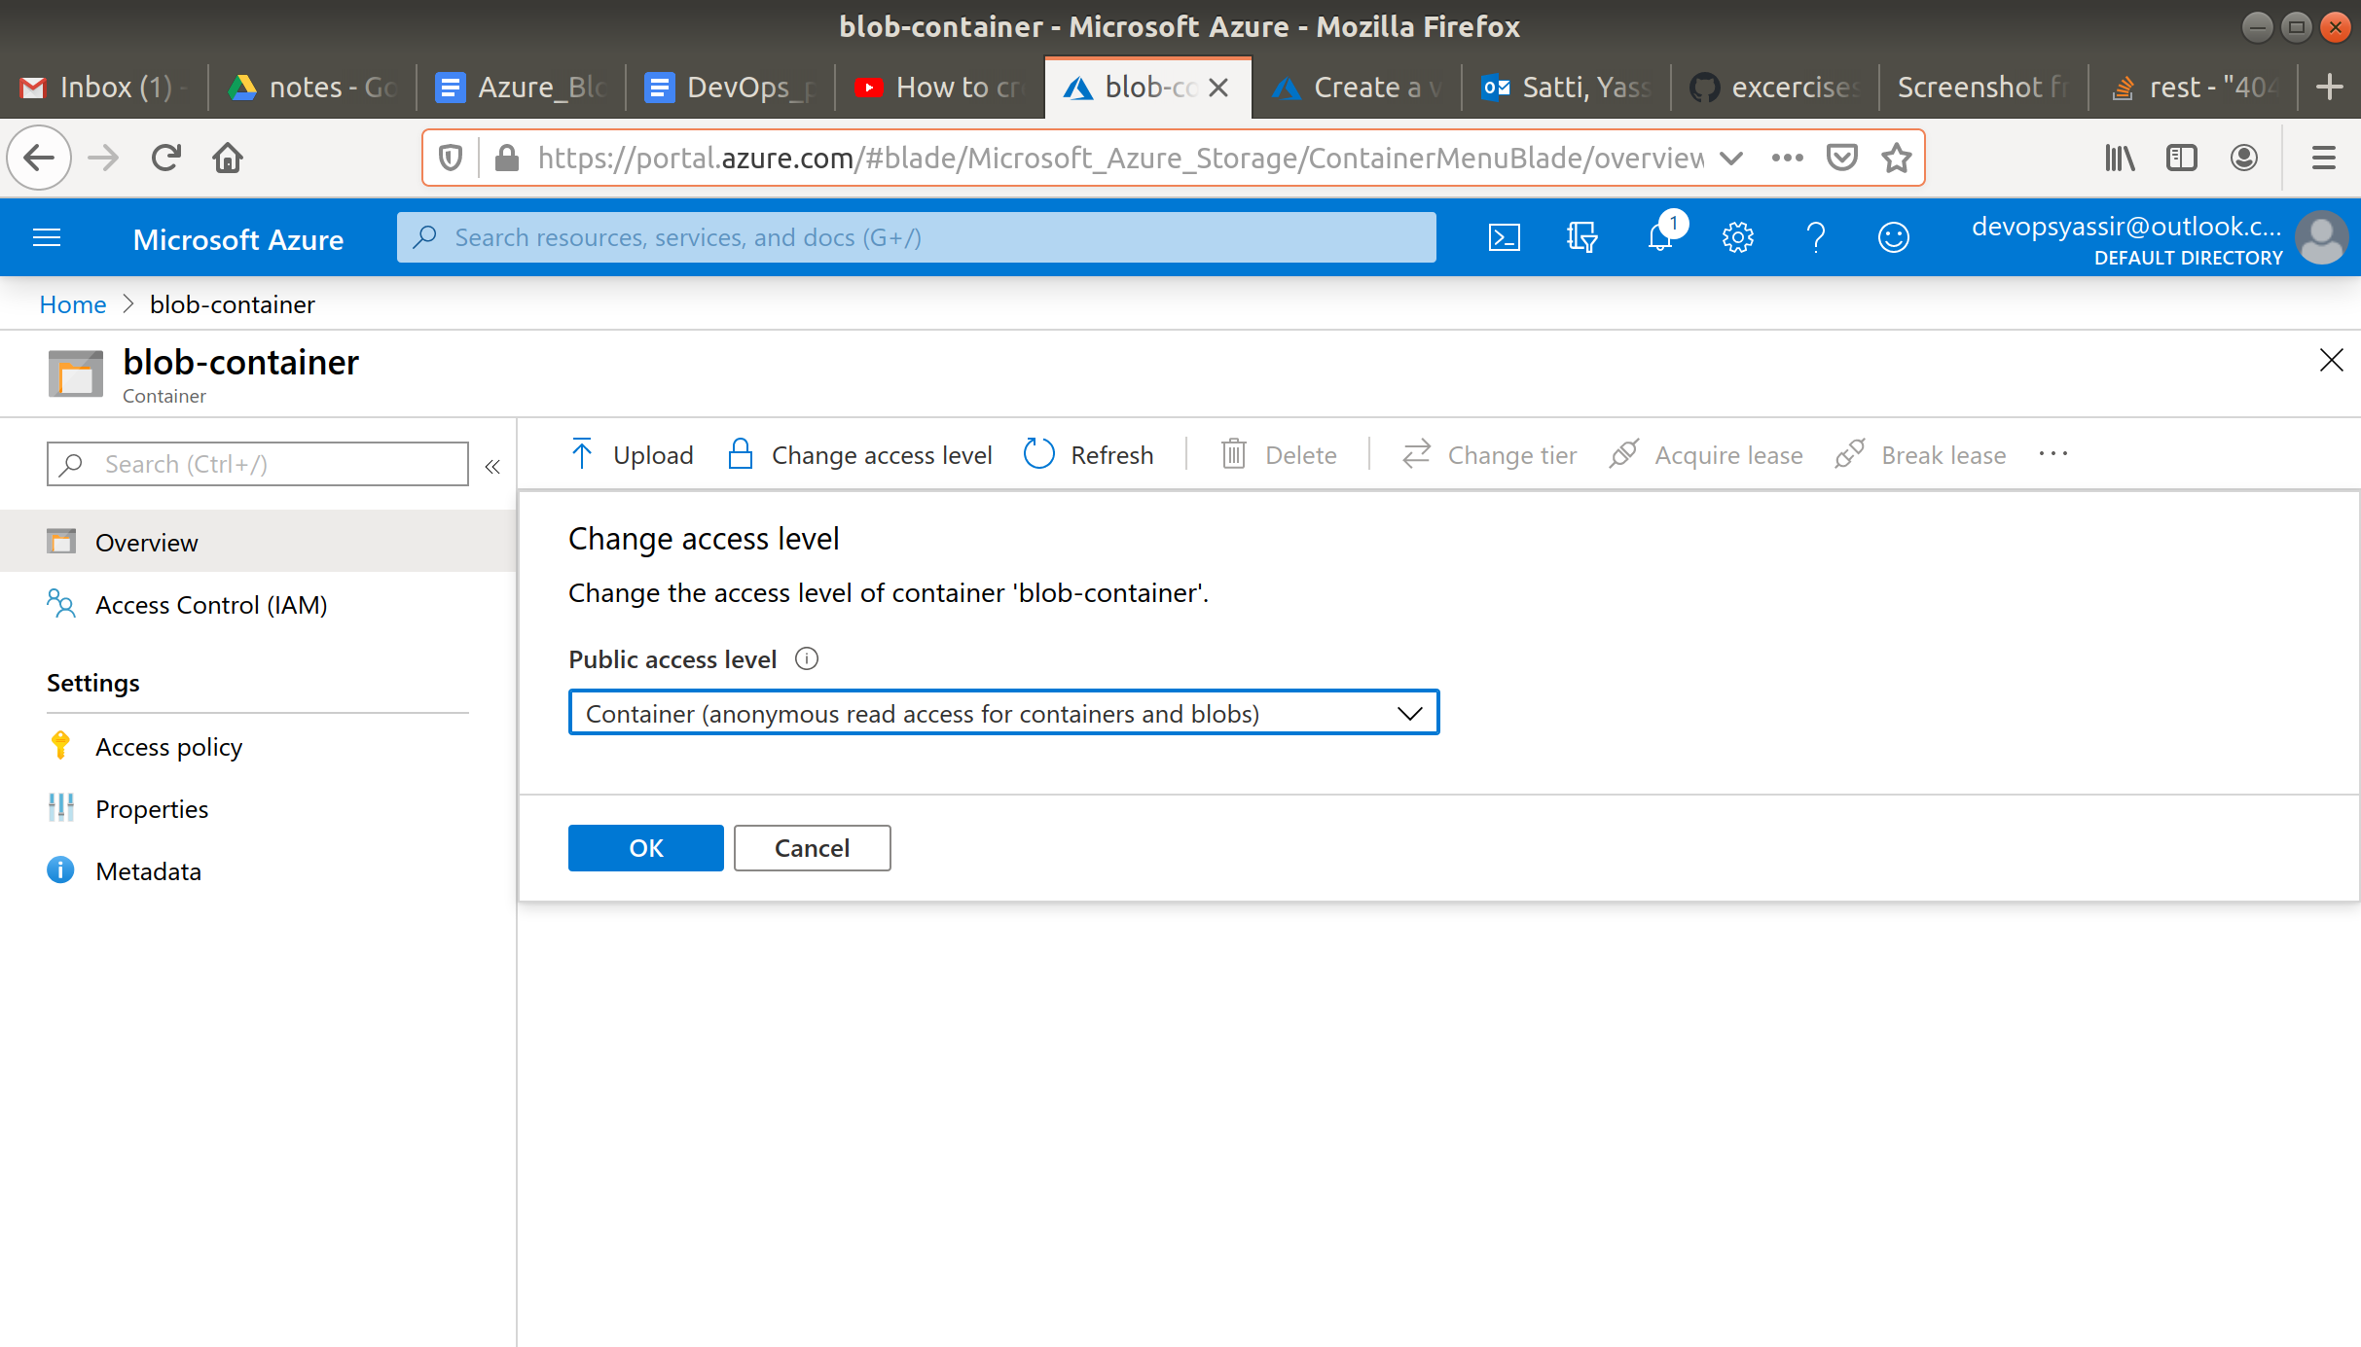

Now if you click on the image you have uploaded, copy the URL and paste it in a new window, you will see the image you just added.

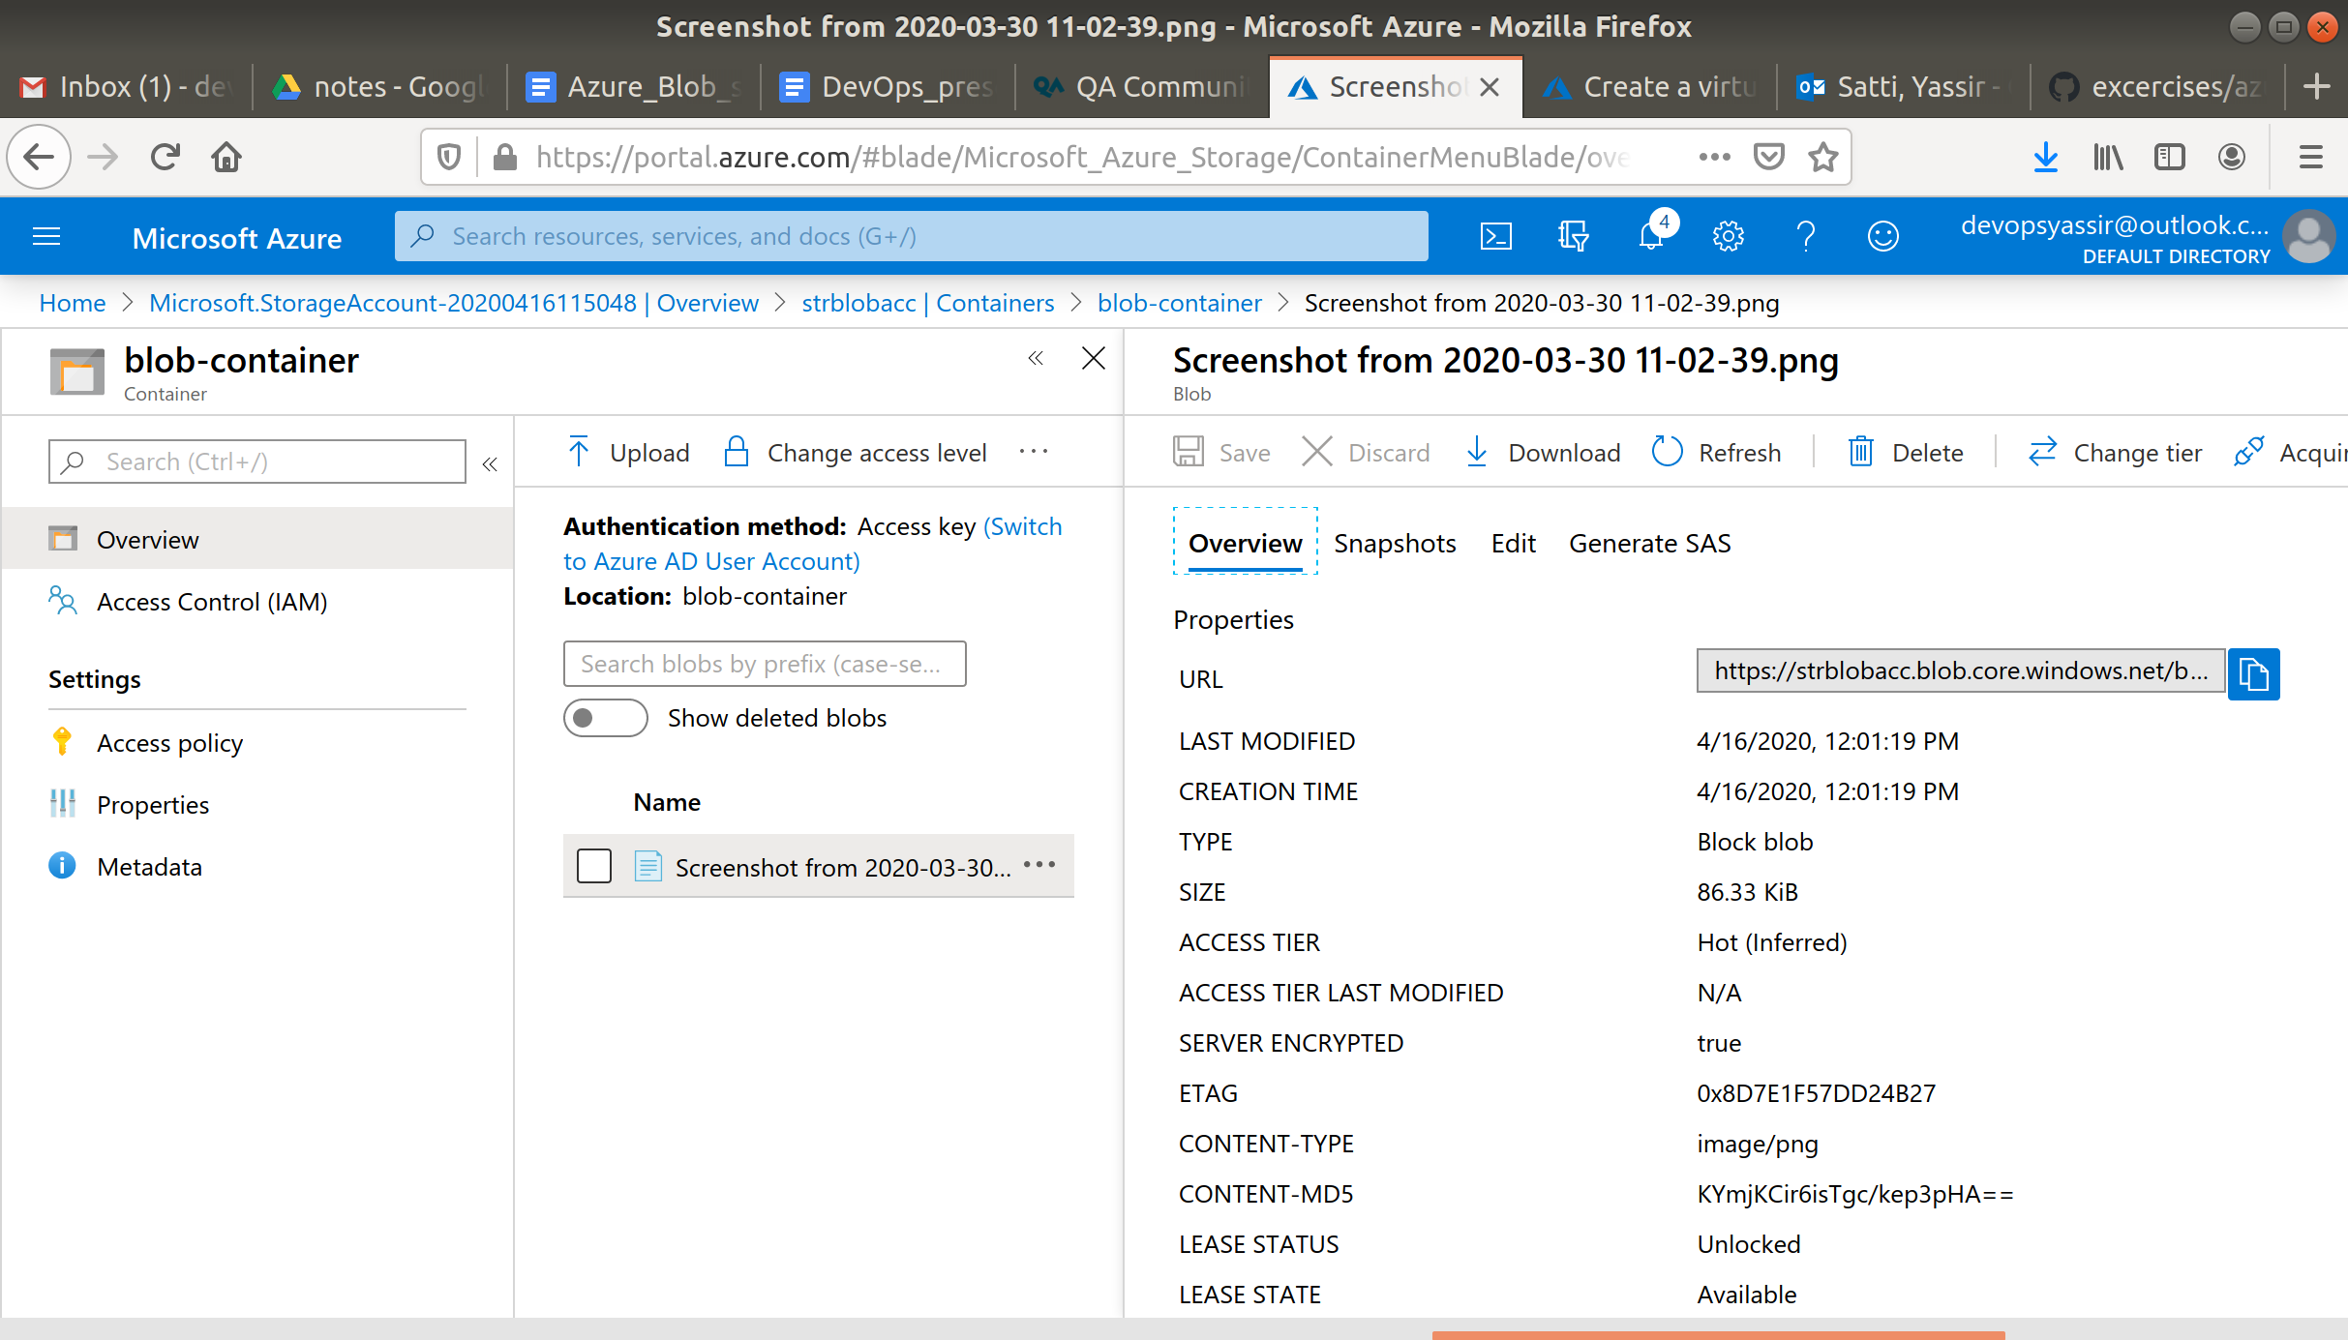

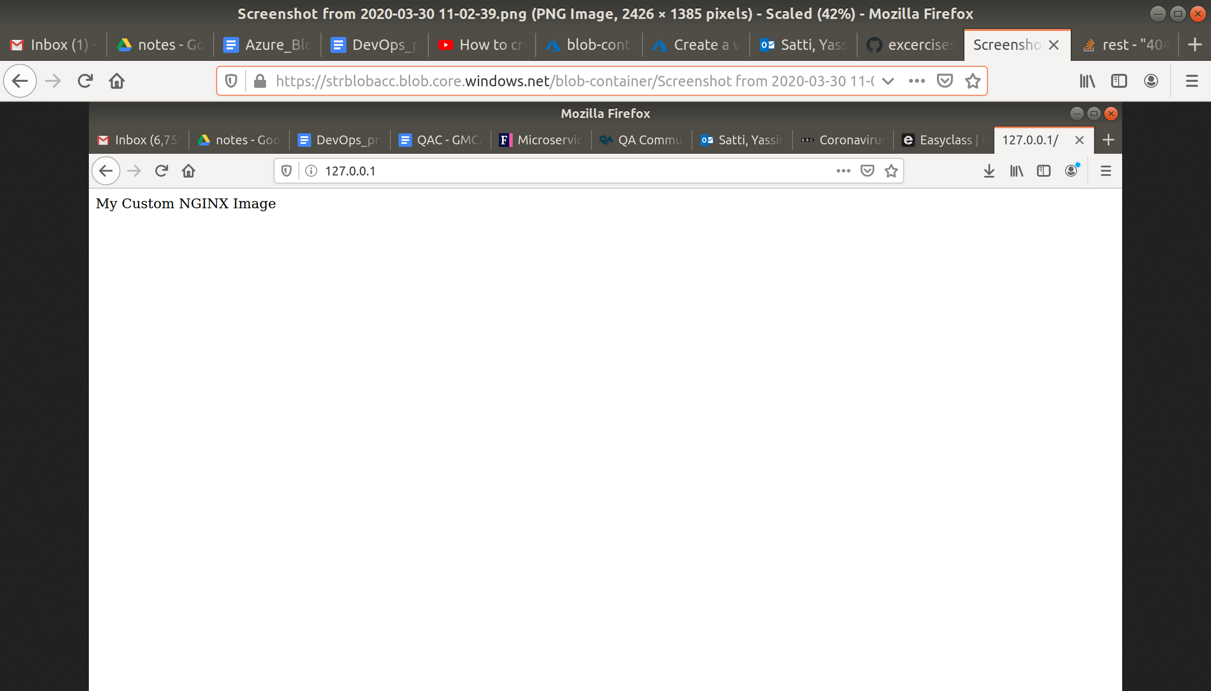

### **Clean Up**

To clean up, go back to the Resource Group page, click your resource group you used for this module, and then choose Delete.

Once you type the name of the resource group to confirm deletion, this will be deleted along with everything inside of it.